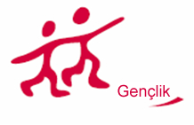 | 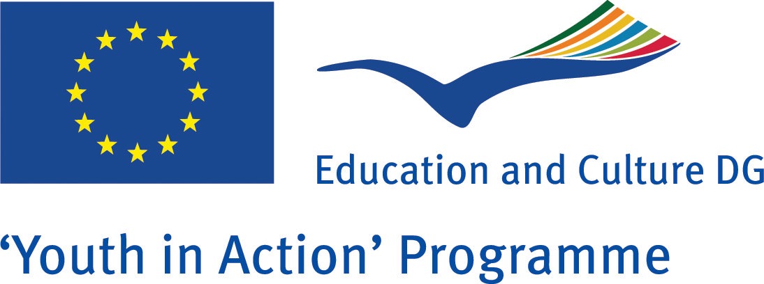
Name of the Organization | Group Behçet Patients (GBD)
Name of the Project | Behçet Desaese
Date of the Project | 10-16 January 2011
Venue of the Project | Turkey
Type of the Project | Action 4.3 Training Course
Thema of the Project | Health
Summary of the Project | Behçet Desaese project is going to be implemented in Turkey. Its activity is going to be between 10-16 January 2011. It will be directed by Group Behçet Desaese Patients. It will be a Training Course for 6 days. The project language will be English. The participants will be trained and informed on Behçet desaese, the effects of it and also treatments ways. In this training our first aims are; to find out how this deasease effects person’s organs and daily life, the ways to minimize the effects of that desaese and learning new methods and techniques which are used in partner countries. And also the participants will exchange their experiences and knowledges about Behçet Desaese.
Objectives | - To profit the presence of different organizations to develop ideas for new youth projects within the Youth Programme.  - Identify the main reasons, signals and effects of Behçet deasease.  - To get knowledge about different methods and techniques used in partner countries  - To create empathy to understand Patients of Behçet Desaese  - Visiting the Behçet desaese patients and their doctors in hospital to see what kind of treatments they are using.  - To offer the opportunity to meet Behçet desaese patients and the experts to be able to get more knowledge.  - To create awareness for Behçet desaese Patients in an international level  - To share the experiences and knowledge on cultures.  - To create partnership for Action 5.1 project.  - To disseminate the results of the project to wider area.
Methodology | * Ice breakers  * Competitions  * Visual presentations;  * Group work, group discussions and brainstorming;  * Presentation of the Youth Program;  * Group debates  * Drama  * Workshop  * Visiting hospital, Patients and doctors  * Presentation cultures and countries
Participant Profile | The target group of this training course is composed of youngsters, youth workers and leaders, doctors and patients who;  - are aged 16 - 50  - are directly involved in youth activities with young  people;  - are able to work in English;  - are interested in youth and health policies.
Project Environment | Project will be implemented in Aksaray, Turkey. The workshops and training course will be implemented in a hotel in Aksaray. In total, we will be 6 different organisations and 26 participants.
Reimbursment | The travel costs will be reimbursed by 70%. The participants are to keep the travel invoices, tickets and boarding passes in order to get the reimbursement. Food, Accommodation and cultural visit will be free.
To be a Partner | Please fill in your part III. Send by e-mail in a word format.  After the Project coordinator confirm your part 3 you will be given a fax number to fax it.
Contact | Group Behçet Patients  e-mail: sivisli@gmail.com

